Lesson 2.5 Kinetic energy and temperature

Recommended teaching time for this lesson: 0.5 x 60 minute period

• 15 minutes of explicit teaching

• 15 minutes of suggested classroom activities

• 20 minutes homework

Getting started

Learning intentions & success criteria

|  |  |
| --- | --- |
| I will: | I can: |
| understand the relationship between kinetic energy, thermal energy and temperature. | * recall:   + the definition of thermal energy. * define:   + temperature. * describe:   + average kinetic energy. * explain:   + the relationship between thermal energy, kinetic energy and temperature. |

Key ideas

* The particles in a substance do not all have the same kinetic energy; they fit on a distribution and are discussed as average kinetic energy.
* When an increase in thermal energy causes an increase in the average kinetic energy, temperature increases (without phase change).

Curriculum links

Science understanding

* Explain that a change in temperature is due to the addition or removal of energy from a system (without phase change).

Advice for teaching this lesson

Things to know before you start teaching

This is a fairly straightforward topic, and could be combined with earlier shorter lessons to complete a full 1 hour period comfortably.

Common misconceptions

* In previous units we discussed that gases have higher kinetic energies than liquids, and liquids higher than solids. This is correct except when they have the same temperature such as at a phase change point.

Differentiation strategies

The distribution of kinetic energy for molecules at a particular temperature is not something that most core or support-needing students will need. For them emphasise that as long as they understand that there is a direct connection between kinetic energy and temperature, they have grasped the main concept. More-advanced students might like to consider the binomial distribution.

Starter activity: Venn diagram recap

Approximate time: 10 minutes

**Activity placement:** Place directly after Lesson overview

**Activity summary:** A self-task to practice summarising written notes into a visual form.

Notes for the teacher

Encourage students to draw the circles with enough overlap to write a sentence in the coloured section in the instructions, but enough white spaces on the outer segments to write two sentences. You could demonstrate this on the board.

At the end of the lesson, you can refer back to the diagram created and ask students to consider whether water and steam at 100°C have different kinetic energies if they have the same temperature. The answer is no, they have the same kinetic energy, and they will learn more about the ‘why’ in Module 3.

Instructions for students

Step 1: Draw a Venn diagram for the three states of matter consisting of three circles. An example is provided below that you may wish to start from. The colours are just for reference and have no meaning.

Step 2: Label the three outer circles with the three states of matter.

Matter Venn diagram

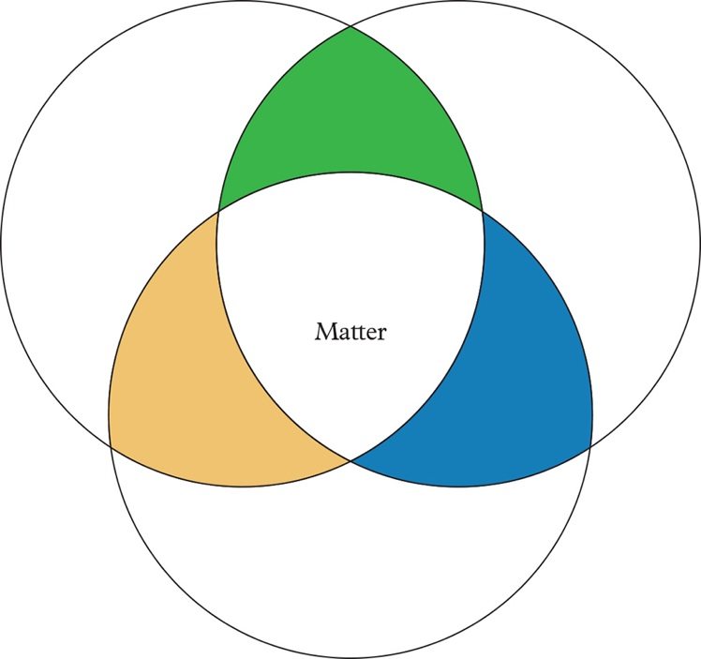

* 1. Use the information in Table 1 of Lesson 2.3 to put a summary of the properties of each of the different states of matter in the relevant circles of the Venn diagram.
  2. State which two phases of matter are most similar to each other. Use the information in the Venn diagram as justification for your decision.

Helpful hints

* + The three coloured sections are where your similar properties will be, while the other white sections are for notes that only apply to one state of matter. The middle section belongs to all states of matter and has been started for you.

Answers

<Note to production: restart numbering below at ‘a.’>



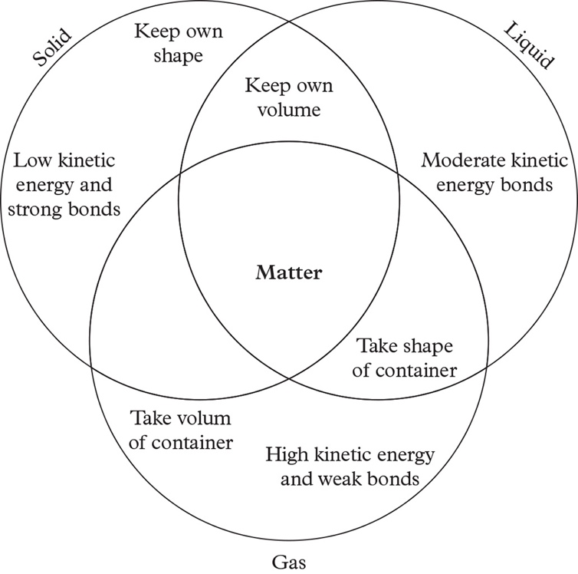

* 1. Student answers will vary between solid and liquid, or liquid and gas. The following is a sample justification.  
     “Both solids and liquids share the property of keeping their own volume when moved between containers; however, solids keep their own shape. They have similar amounts of kinetic energy due to the small amounts of movement of the particles, though liquids can move more due to having weaker bonds between the molecules.”  
       
     Suitable student answers should draw on the critical features of each phase. The only incorrect argument is that solids and gases are the most similar.

Classroom activity: Kinetic energy of people

Approximate time: 5 minutes

**Activity placement:** Place directly above “How does heating affect kinetic energy and temperature?”

**Activity summary:** Students to watch a video of a large crowd of people to consider how kinetic energy is distributed within a compound.

Notes for the teacher

The video is available at: <https://www.youtube.com/watch?v=Bi61ue_cpMY>

Any other video of a large number of people crossing an intersection would also be suitable.

Encourage students to notice how different people cross the road at different rates, with some overtaking others and some sprinting ahead at the start.

Instructions for students

Step 1: Watch the video link below, or your teacher will play it for the class.

Shibuya Crossing <https://www.youtube.com/watch?v=Bi61ue_cpMY>

Step 2: Shibuya crossing is approximately 50 m × 50 m. The vertical, horizontal and diagonal crossings all move at the same time.

<Note to production: restart numbering below at ‘a.’>

* 1. Identify if people are moving at the same speed as each other in the video.
  2. Explain how this is similar to the distribution of kinetic energy in a substance.

Helpful hints

* Remember that kinetic energy is a representation of the movement of particles, so what is the movement of the people like?

Support activity

Notes for the teacher

These instructions are more scaffolded to help students consider their reasoning.

Instructions for students

Step 1: Watch the video link below, or your teacher will play it for the class.

Shibuya Crossing <https://www.youtube.com/watch?v=Bi61ue_cpMY>

Step 2: Shibuya crossing is approximately 50 m × 50 m. The vertical, horizontal and diagonal crossings all move at the same time. At 40 seconds, when people start to cross, notice how some are racing off ahead of the others. At about 50 seconds there is a group of slow moving people in suits in the bottom left of the video.

<Note to production: restart numbering below at ‘a.’>

* 1. If there are slow-moving people and fast-moving people, is this the same for the molecules in a substance at a set temperature?

Challenge activity

Notes for the teacher

This activity will push students to consider patterns shown in graphs, and realise that mathematics sometimes identifies properties that go against common sense.

Instructions for students

Step 1: Watch the video link below, or your teacher will play it for the class.

Shibuya Crossing <https://www.youtube.com/watch?v=Bi61ue_cpMY>

Step 2: Shibuya crossing is approximately 50 m × 50 m. The vertical, horizontal and diagonal crossings all move at the same time.

<Note to production: restart numbering below at ‘a.’>

* 1. Identify if people are moving at the same speed as each other in the video. If you’re not sure where to start, try considering the following.
  2. Explain how this is similar to the distribution of kinetic energy in a substance.

Step 3: Consider the graph in Figure 2 in Lesson 2.5.

<Note to production: restart numbering below at ‘c.’ **NOT** ‘a.’>

* 1. Sketch what you think the graph would look like at 2,000°C and then at 10,000°C.
  2. Identify what this means about the speed of particles at super-hot temperatures such as in a star.

Answers

<Note to production: restart numbering below at ‘a.’>

* 1. No, people are moving at different speeds.
  2. The people moving at different speeds will therefore have different kinetic energies. This is the same as particles in a substance – they each have different kinetic energies. But there is an average that the people – and the particles – are spread around.

Support activity

<Note to production: restart numbering below at ‘a.’>

* 1. Yes. There are fast and slow moving people, the same way there are fast and slow moving molecules.

Challenge activity

<Note to production: restart numbering below at ‘a.’>

* 1. No, people are moving at different speeds.
  2. The people moving at different speeds will therefore have different kinetic energies. This is the same as particles in a substance – they each have different kinetic energies. But there is an average that the people – and the particles – are spread around.
  3. Graphs will be similar in shape to Figure 2 with a peak that is smaller in height but shifting to the right along the speed axis at each higher temperature. The graph line must start at the origin.
  4. This means there is a non-zero chance that there is a particle with a very low speed inside something as hot as a start. But there is also a non-zero chance that there is a particle with extremely high speeds as well.